PORTFOLIO
CA ASSIGNMENT OF CSE111 (ORIENTATION TO COMPUTING-1)

COMPUTER SCIENCE AND ENGINEERING
Submitted by:
Name: Soumya Singh Registration number: 12513179
Roll No.: 61 Section: K25HA

Submitted to: Mr Rajeshwar Sharma


LOVELY PROFESSIONAL UNIVERSITY

DECLARATION
I, Soumya Singh, a student of Bachelor of Technology under CSE discipline at Lovely Professional University, Punjab, hereby declare that all the information furnished in this project report is based on my own work and is genuine.

Name: Soumya Singh Registration No: 12513179

Platforms for profile creation | Link to student profile | Page number
Figma | https://www.figma.com/make/ s9VaM97M6FXeSXSM6XdxUH/  Design-Colorful-Restaurant-Logo?node- id=0-4&t=iwAbLPCgSi4bLEG0-0 | 1
Leet code | https://leetcode.com/u/SoumyaSingh922/ | 2
Stack overflow | https://stackoverflow.com/users/31971271/soumya- singh | 4
Hacker Rank | https://www.hackerrank.com/profile/ soumya_singh0214 | 5
Hacker Earth | https://www.hackerearth.com/@soumya.singh0214 | 3
Geeks for Geeks | https://www.geeksforgeeks.org/profile/soumyasih61a | 6
Github | https://github.com/soumyasingh0214 | 9
LinkedIn | https://www.linkedin.com/in/soumya- singh-2a42ab398/ | 7
Figma Logo | https://www.figma.com/make/ s9VaM97M6FXeSXSM6XdxUH/  Design-Colorful-Restaurant-Logo?node- id=0-4&t=iwAbLPCgSi4bLEG0-0 | 1
CV |  | 8

Technical mooc registration proof | https://learn.upgrad.com/course/1381 | 10

Paste screen shots of all given in the table as proof:

Page 1
Figma Logo

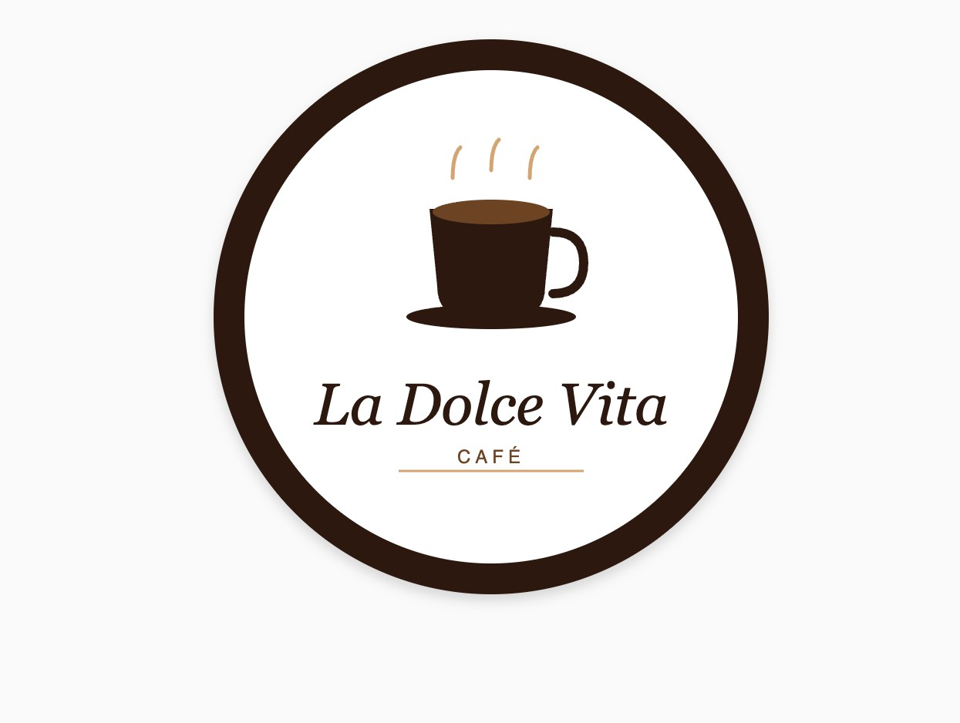
Page 2
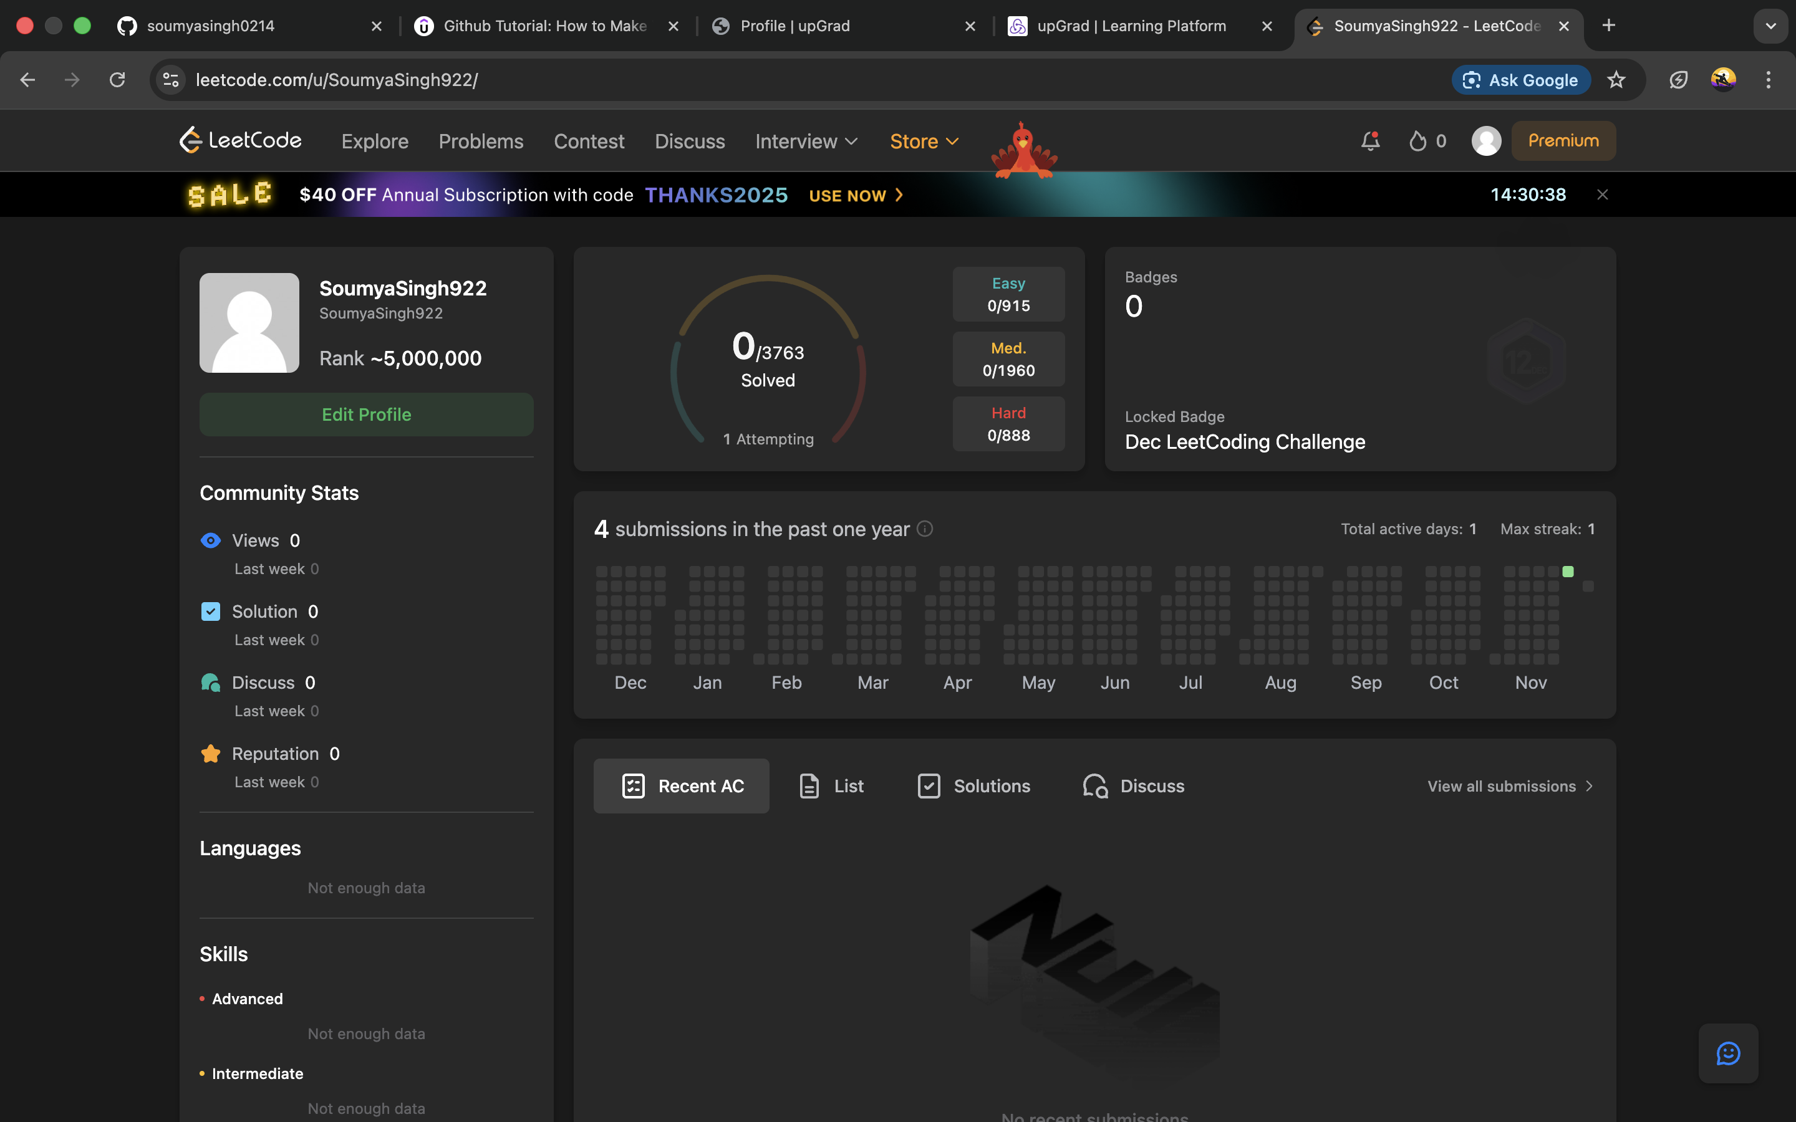
LeetCode

Page 3
Hackerearth

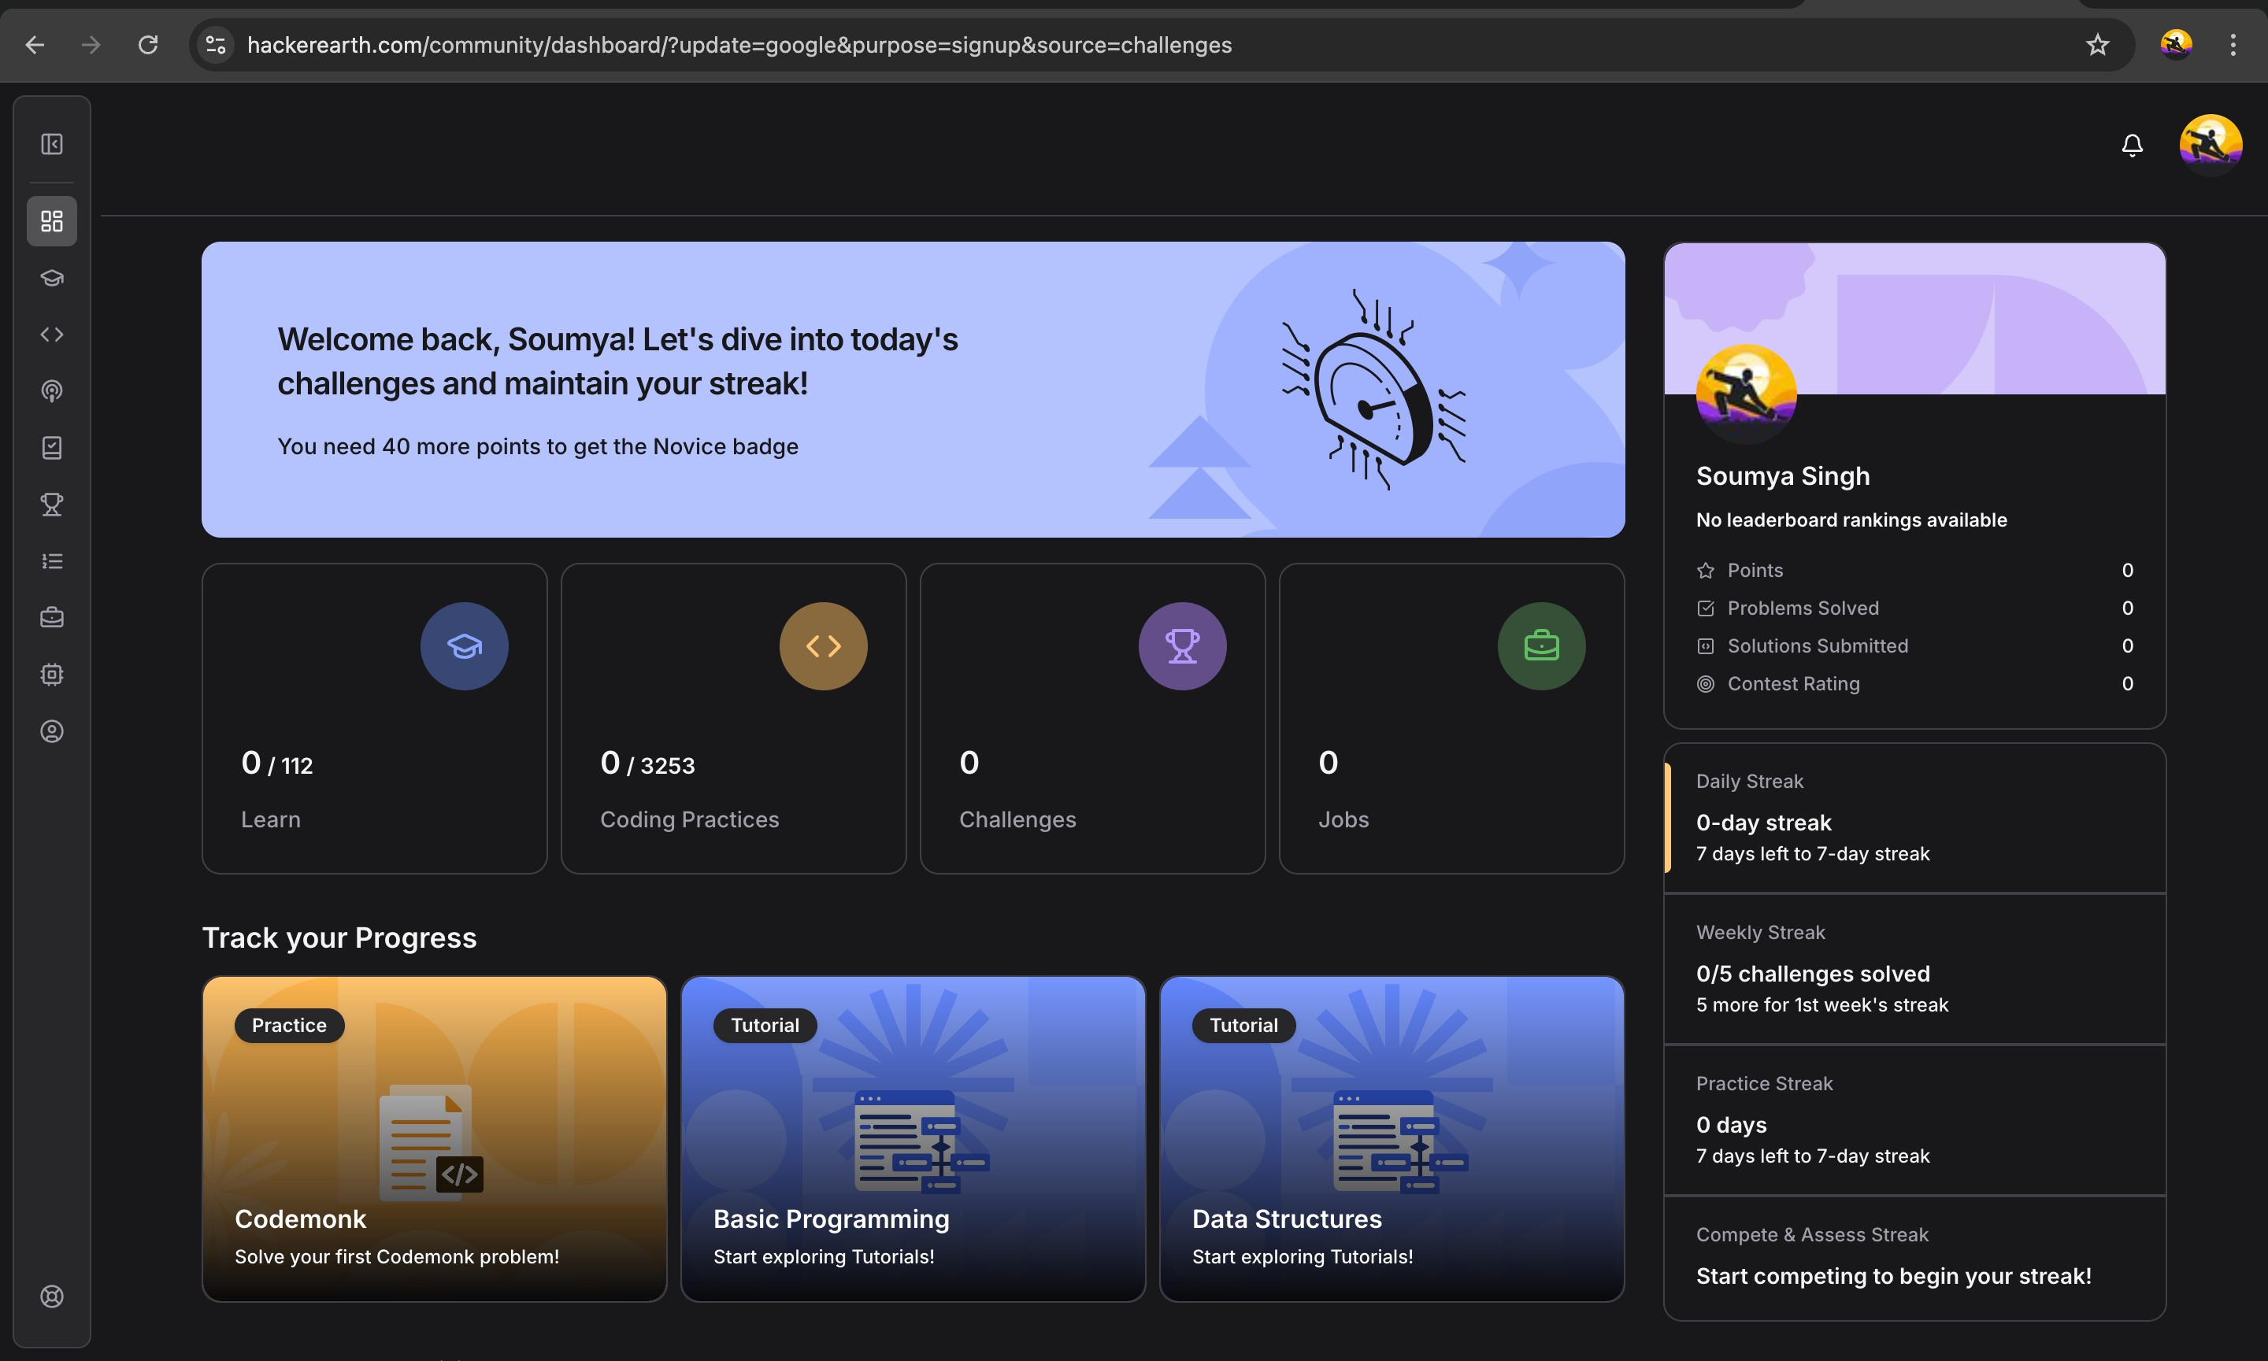

Page 4
Stack OverFlow

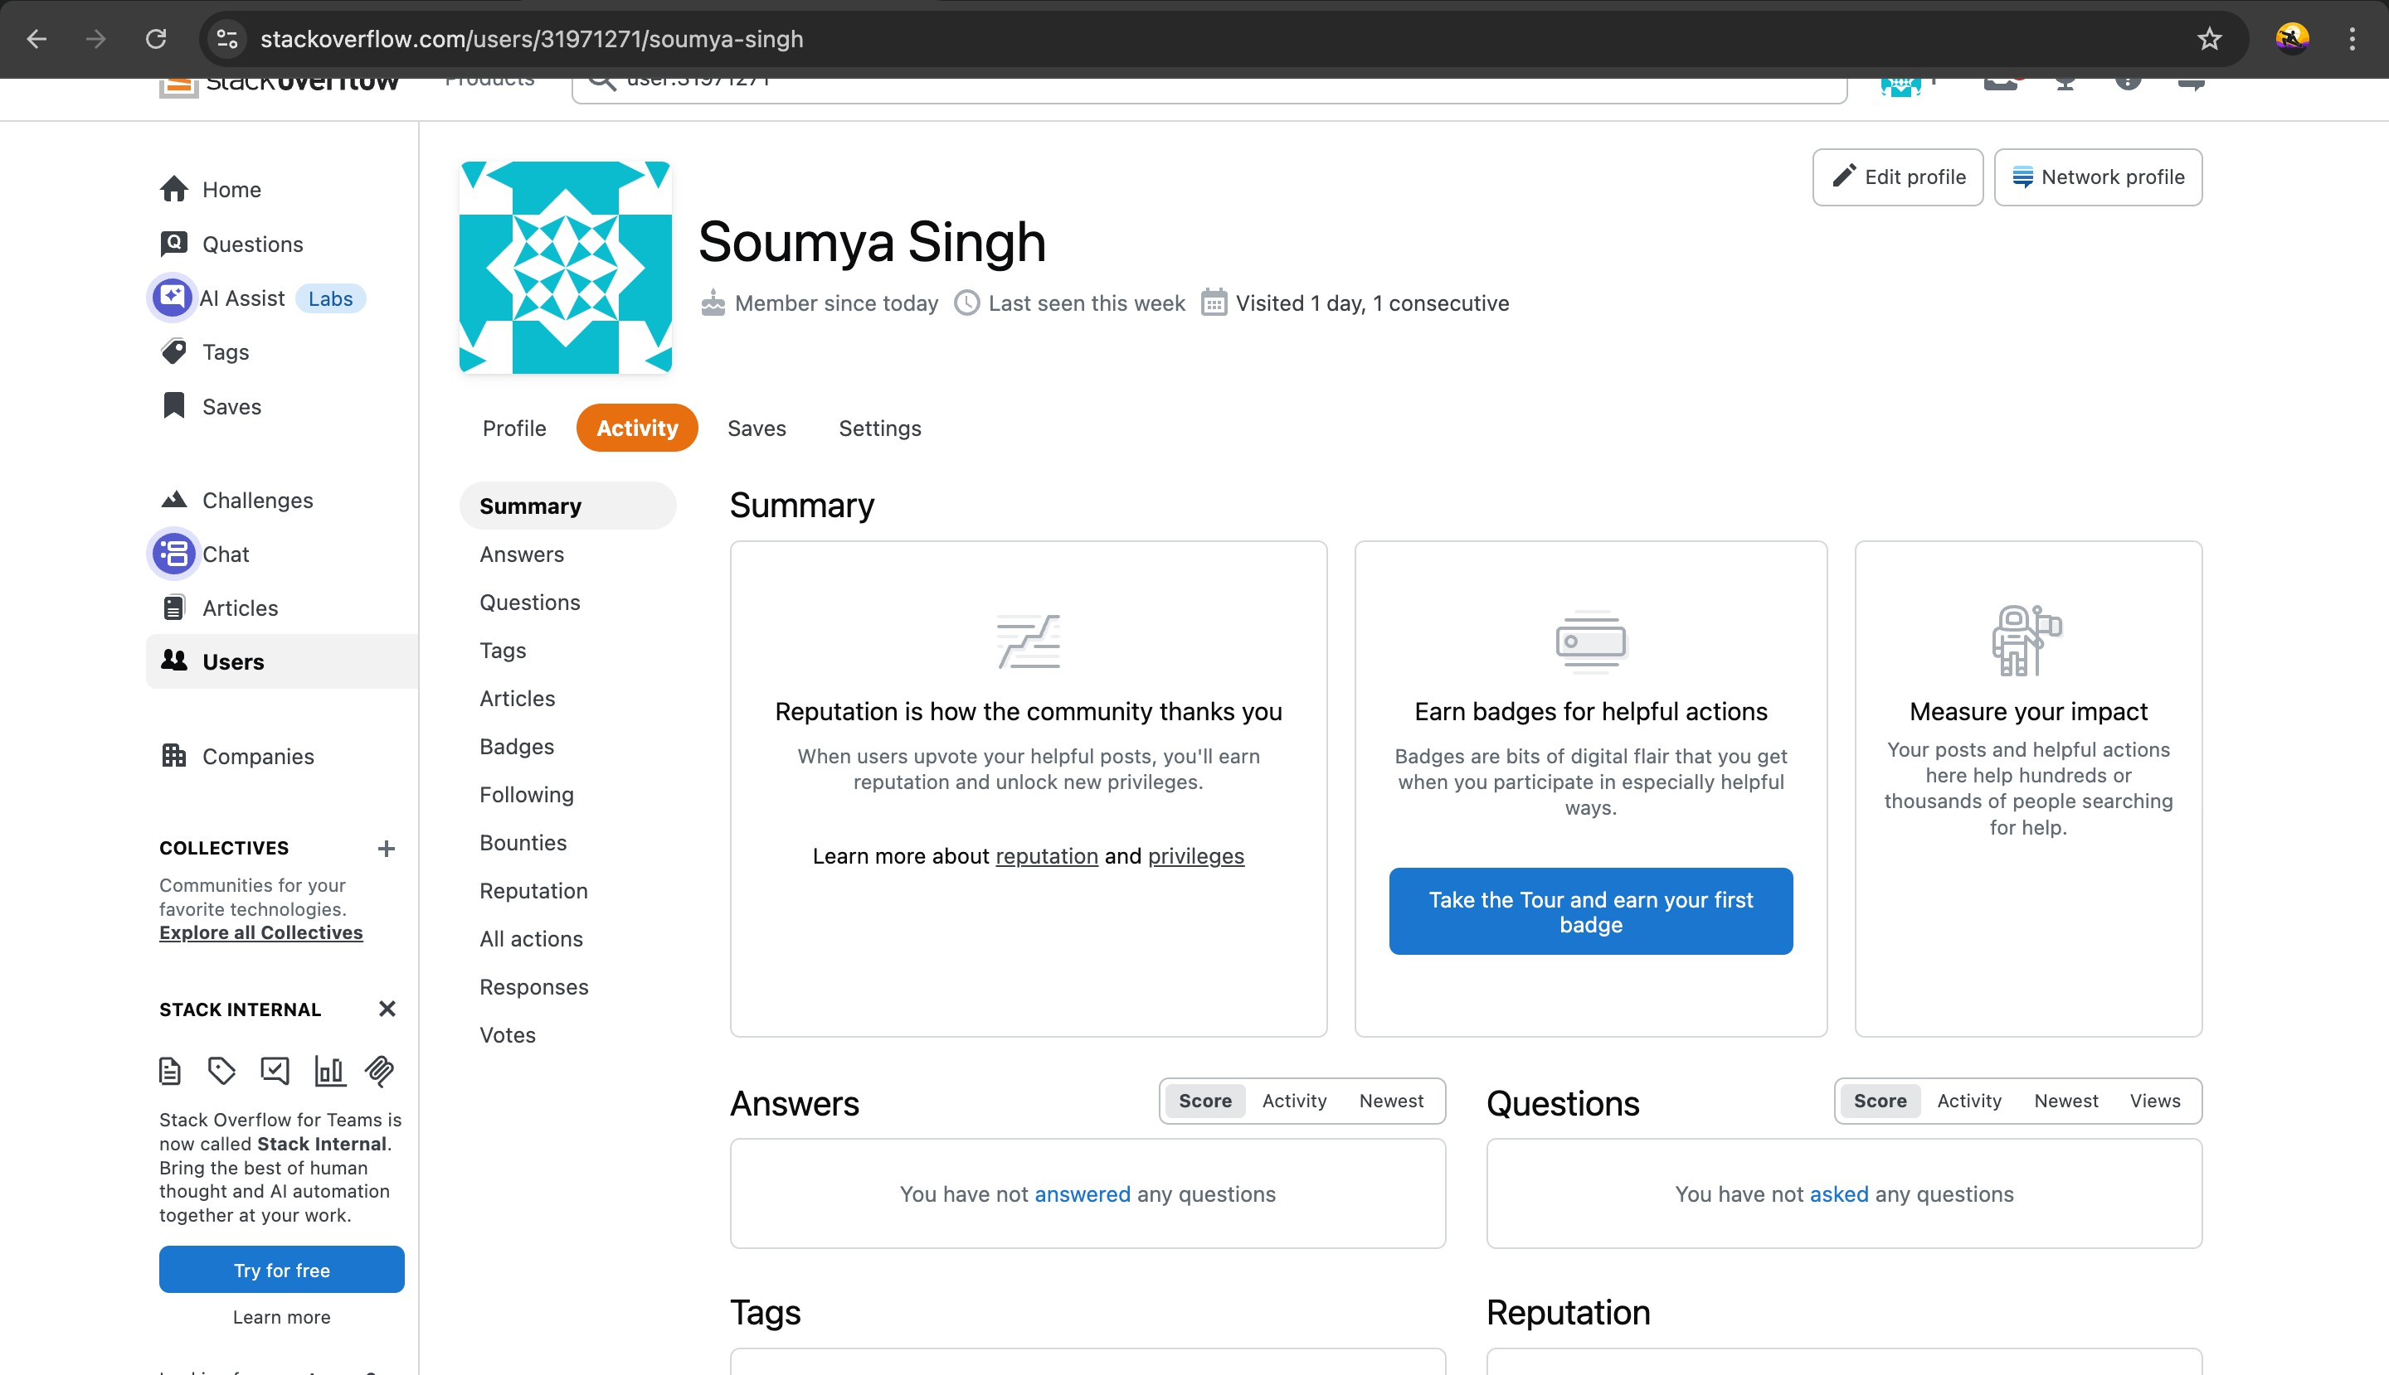

Page 5
HackerRank


Page 6
Geeks For Geeks

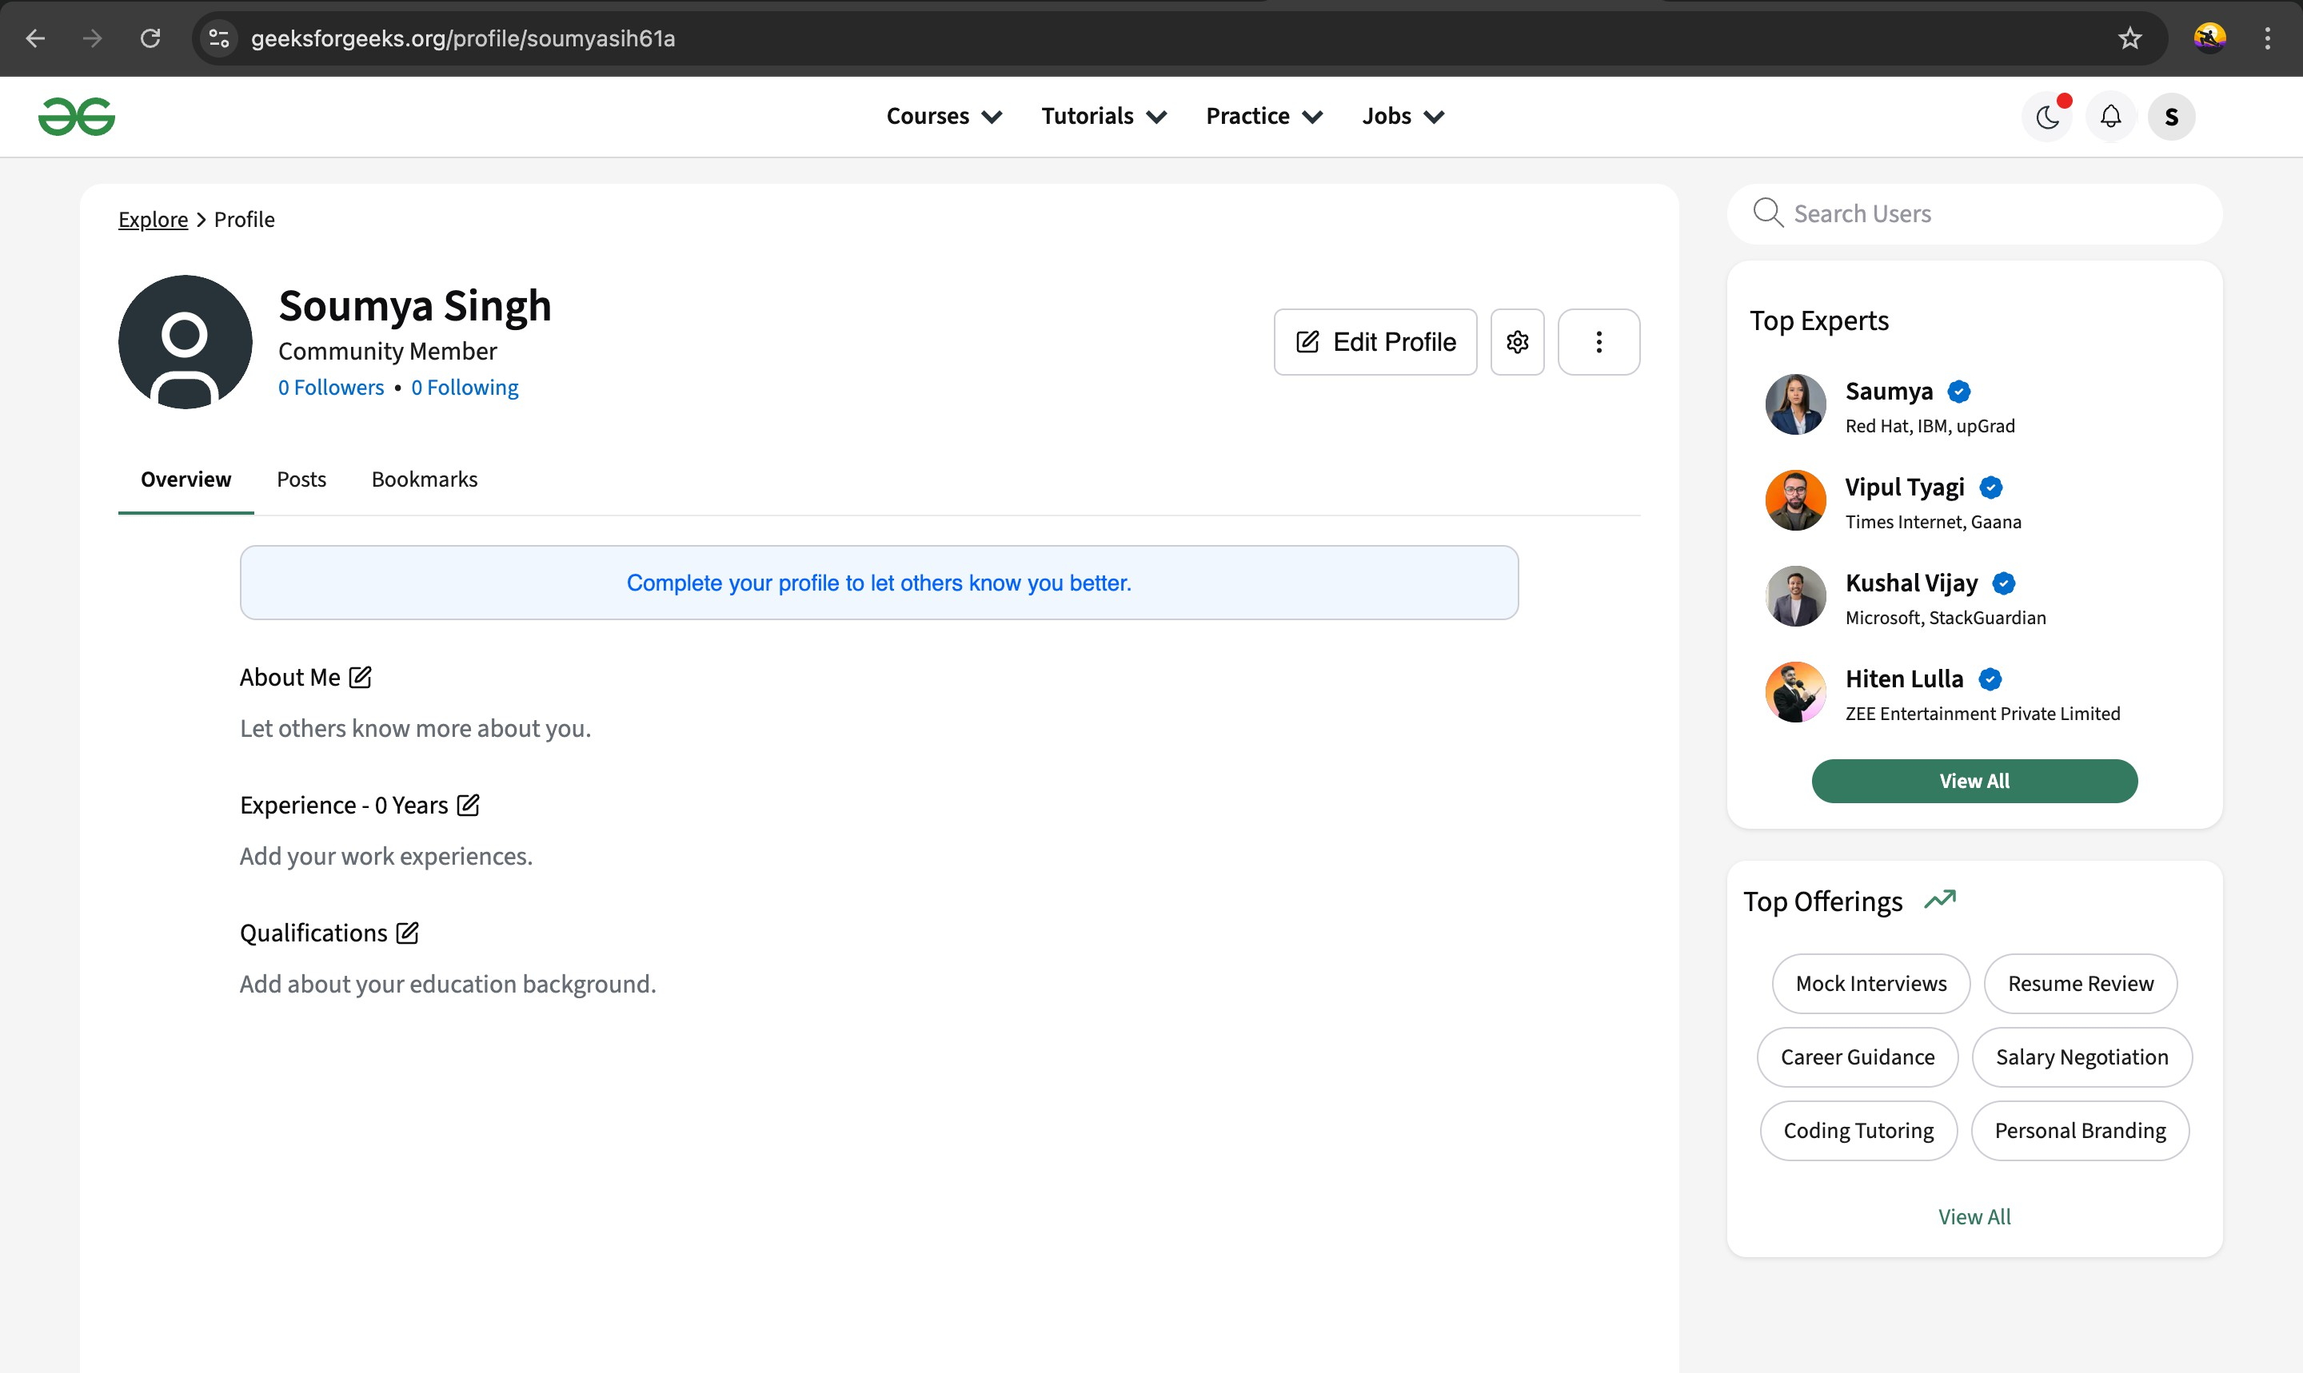
Page 7
Linkedln

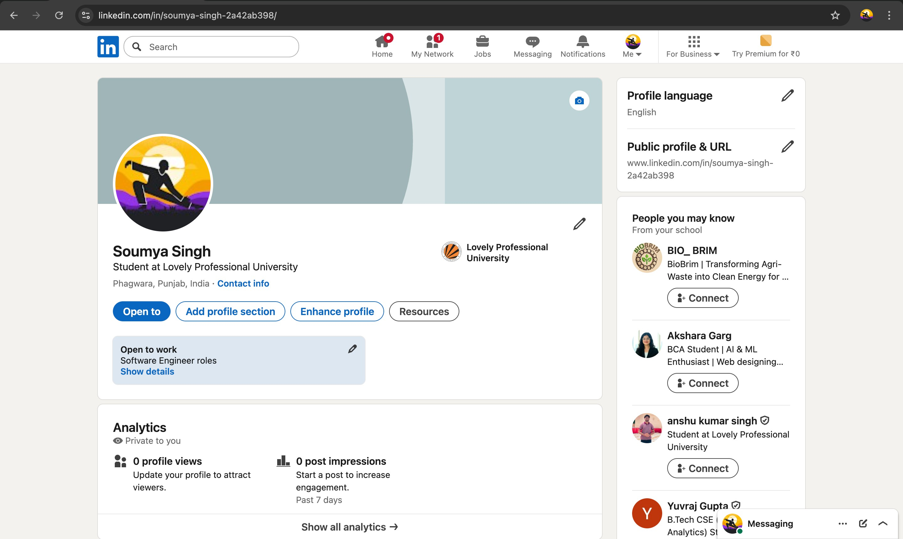
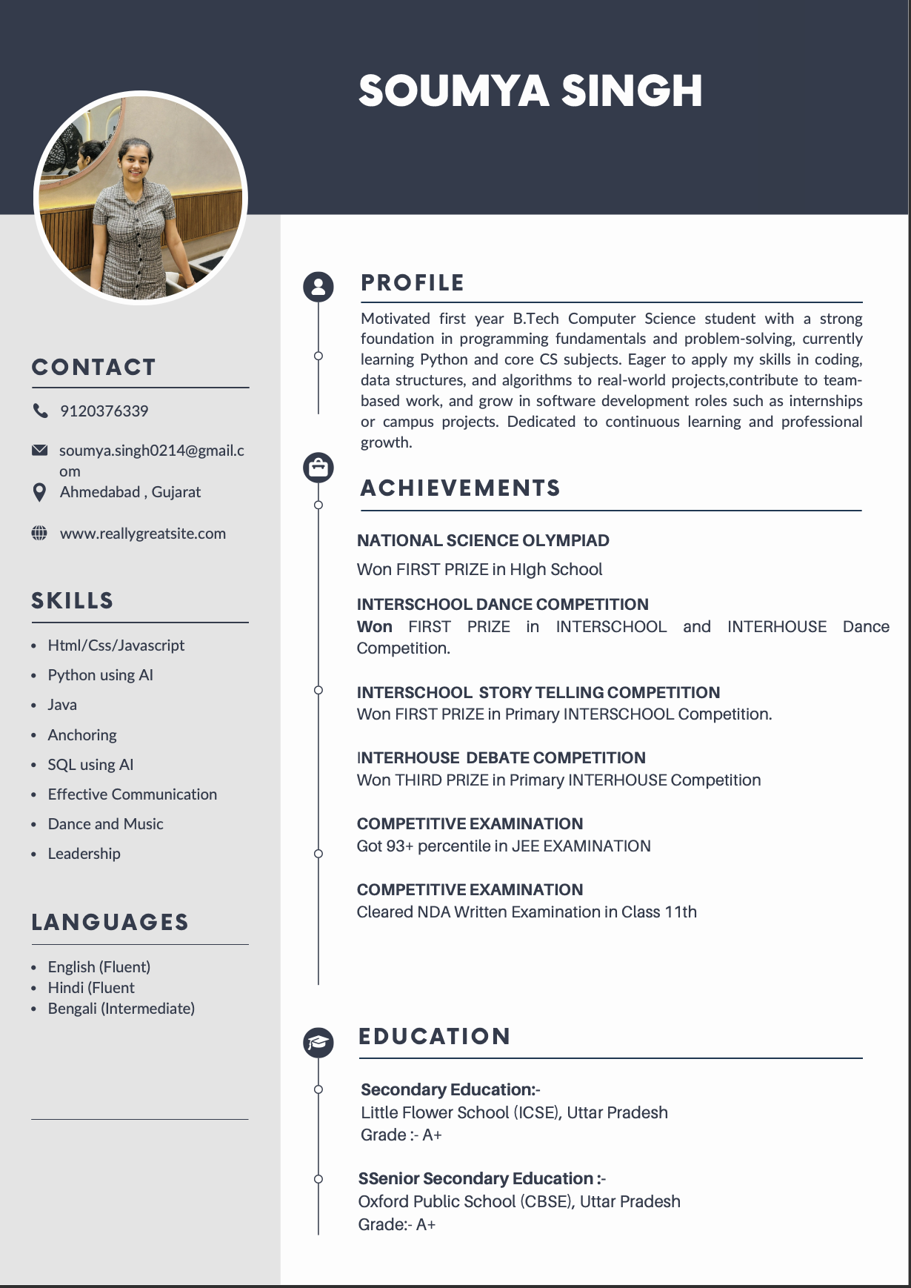

Page 8

CV
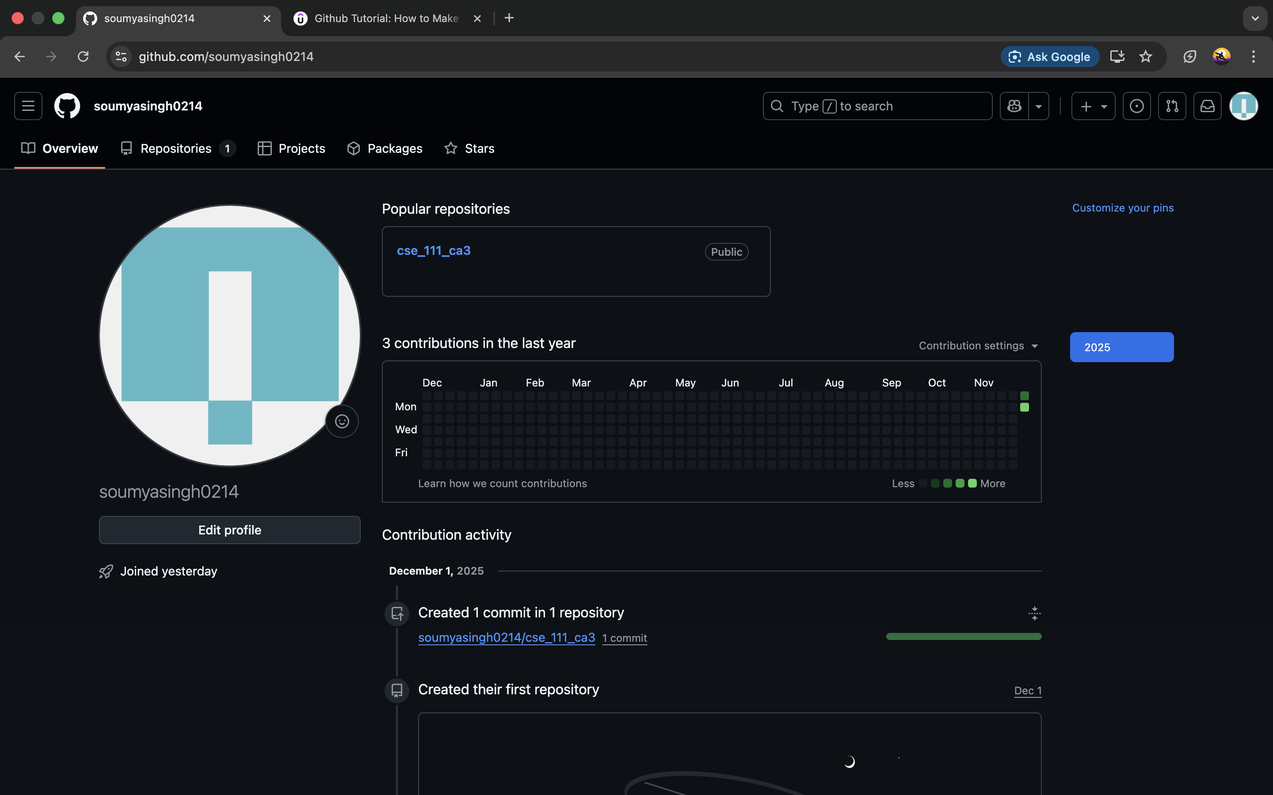

Page 9

Github
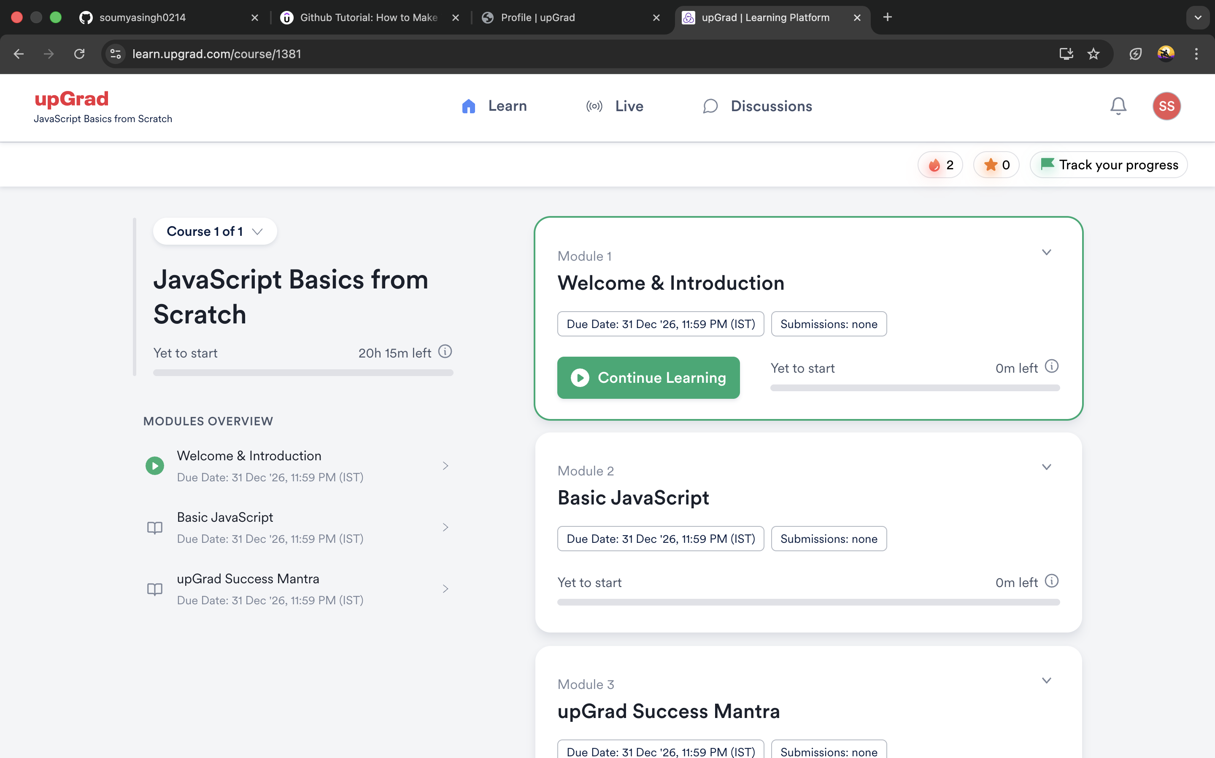

Page 10

Technical MOOC Registration Proof

